**MYOTHERAPY/REMEDIAL MASSAGE NEW PATIENT FORM**

**Mr Mrs Ms Miss Master Other__________**

**First Name**: …………………………………………… **Surname**……………………………………………. **Date**: ………/….…/………

**Address**: ……………………………………………………….. **Suburb**………………….. **Postcode**……… **DOB:** ……/……/……….

**Phone no: Home**: …………………………...... **Work**….……………..……..................... **Mobile**:………………………………….…..

**E-mail** ………………………….….………………….……………… **Partner/Spouse**: ………………… **No. of Children**: ………….

**Occupation**: ……………………………………… **Who recommended you to this centre**? …………………………………………

**Medical Doctors Name …………………………………………….. Medical Centre Name …………………………………………….**

**Are you responsible for this account**? Yes WorkCover TAC Veterans

**Do you have private health coverage**? Yes/No If yes, which fund ……………………………………..…………………….........

**Emergency contact** ……………………...….…… **Phone number** ..…………………….…. **Relationship**………………….……….

**ABOUT YOUR HEALTH**

1. **Why are you here?** ……………………………………………………………………………………………………………….............
2. **Have you seen a Myotherapist/Remedial Massage therapist? (please circle) If so, please answer the following:**

|  |  |  |  |
| --- | --- | --- | --- |
| My previous experience of Myotherapy/Massage was: | Poor | Average | Excellent |

1. **Have you ever been diagnosed as having any of the following? C = Current P = Past**

|  |  |  |  |  |  |  |  |  |
| --- | --- | --- | --- | --- | --- | --- | --- | --- |
|  | **C** | **P** |  | **C** | **P** |  | **C** | **P** |
| Fractures |  |  | High/Low Blood Pressure |  |  | Metal implants/plates/screws |  |  |
| Hospitalization |  |  | High/Low Blood Glucose |  |  | Lung conditions e.g asthma |  |  |
| Surgery |  |  | Heart problems |  |  | Blood disorders |  |  |
| Incontinence |  |  | Epilepsy |  |  | Rheumatoid arthritis |  |  |
| Regular headaches/migraines |  |  | Osteoporosis |  |  | Thyroid dysfunction |  |  |
| Allergies/food intolerances |  |  | Unexplained weight loss |  |  | Stroke |  |  |
| Diabetes |  |  | Cancer |  |  | Anaemia |  |  |
| Neurological conditions |  |  | Kidney disease |  |  | Multiple Sclerosis |  |  |

1. **a. Do you smoke?** Yes / No **b.** **Do you drink?** Yes / No
2. **Now or in the past have you ever experienced any of the following: C = Current P = Past**

|  |  |  |  |  |  |  |  |  |
| --- | --- | --- | --- | --- | --- | --- | --- | --- |
|  | **C** | **P** |  | **C** | **P** |  | **C** | **P** |
| Dizziness/light-headedness |  |  | Being knocked unconscious |  |  | Pins and needles or numbness |  |  |
| Fainting or blackouts |  |  | Pain waking you at night |  |  | Pain on coughing/sneezing |  |  |

1. **Are you, or could you be pregnant?** Yes / No
2. **What are three things you can’t do because of your pain in the last week?**
3. **…………………………………………… 2…………………………………………… 3. ……………………………………………**
4. **What are three health goals you would like to achieve, and in how long?**

**1. ………………………………………….. 2…………………………………………… 3. ……………………………………………**

**9. List your current medications/supplements below  
  
 ……………………………………………………………………………………………………………………………………………….**

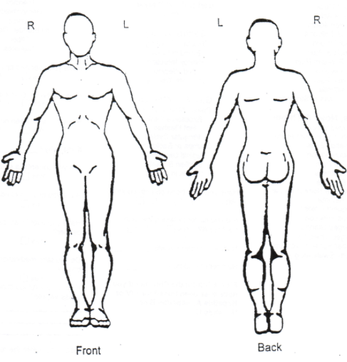

**MEASURING YOUR PAIN LEVELS:**

**Please label the diagram to Please circle your *current* pain levels**

**the right with the following:**

No Pain Unbearable Pain

|  |  |  |  |  |  |  |  |  |  |
| --- | --- | --- | --- | --- | --- | --- | --- | --- | --- |
| **1** | **2** | **3** | **4** | **5** | **6** | **7** | **8** | **9** | **10** |

**Pain: ####**

**Numbness: oooo Please circle your *worst* pain levels**

**in the past week:**

**Pins/Needles: xxxx** No Pain Unbearable Pain

|  |  |  |  |  |  |  |  |  |  |
| --- | --- | --- | --- | --- | --- | --- | --- | --- | --- |
| **1** | **2** | **3** | **4** | **5** | **6** | **7** | **8** | **9** | **10** |

**INFORMED CONSENT**

**Remedial massage/Myotherapy** is a proven therapy to safely relieve tension, reduce pain, and improve movement. Uncommon reactions like treatment pain, bruising, or sleepiness may occur. Answering this form helps minimise risks. You may stop or refuse treatment at any time. Please inform your practitioner of any concerns regarding your medical history, body exposure, or positioning.

**Dry needling** involves inserting fine, sterile needles into specific muscles or trigger points to reduce pain, tension, and improve movement. This is an evidence-based practice that is safe and effective.

**Possible Risks:**

○ Mild discomfort or pain during and after treatment.

○ Temporary bruising, bleeding, or swelling at the needle site.

○ Drowsiness or fatigue after the session.

○ In rare cases, infection or other adverse reactions.

○ Pneumothorax (collapsed lung): In very rare cases, when needles are applied near the chest or interscapular area, there is a small chance of affecting the lung, which may require medical attention. In almost all cases needling provided will occur outside of these risk areas.

**Precautions:**

○ Please inform your therapist if you have a fear of needles, are pregnant, have a bleeding disorder, or are taking blood thinners.

○ Let your therapist know if you feel discomfort beyond what is expected or if any unusual symptoms arise post-treatment.

**CANCELLATION POLICY** The clinic is a very busy clinic. Often we have to place patients on a waiting list as they cannot have their first preference appointment. If a patient cancels an appointment, without a reasonable explanation and within 24 hours of their appointment, the centre will bill a Cancellation Fee of $50 for a 60 minute massage and $30 for a 30 minute massage.

**DO NOT SIGN the following until you have spoken with your Myotherapist/Remedial Massage therapist:**

I understand the above, have been given the opportunity to ask questions and have been satisfied with the answers. Having discussed and understood the practitioners recommendations, I grant permission for care to proceed.

I understand I can withdraw this permission at any time.

Patient’s signature:…………………………………………………………..…………… Date……………/………/…………

(Parent or Guardian if patient under 18)

Patients Name (Please print) ……………………………………………………………Practitioners signature…………………...